Right to Lift

Usage of Right to Lift Data Exchange Standards for

Downstream Europe Road Transport Fuels Movements

Document Properties
Version | 1.0
Last Update | 20-March-2013
Prepared by | Bryan McPadden/Mark Garton
Owner | PIDX International
Contact Information | Bryan.McPadden@telventdtn.com  Mark.Garton@telventdtn.com

Disclaimer
This document is intended to capture field usage detail about the Right To Lift Data Exchange Standard for Oil and Gas Downstream Road Transport Fuels Movements in Europe.

The document is open to all workgroup participants and interested parties to comment on.
Contents
1 Introduction 4
1.1 Purpose of the document 4
1.2 Glossary 4
1.3 PIDX Right To Lift Command Overview 5
1.3.1 PIDX Authorization Request 6
1.3.2 PIDX Authorization Response 7
1.3.3 PIDXBOL 8
1.3.4 PIDXBOLResponse 9
2 Detailed Element Data Population Recommendations 10
2.1 Scenarios using the LoadingType field: 11
2.2 Multiple Parties in the AuthParties structure 12
2.2.1 One Party Example 12
2.2.2 Two Party Example 13
2.3 Cancelled Loads – No Load BOLs 13

Introduction

Purpose of the document
The Right to Lift XSD contains a set of messages used as the data structures for exchanging data between the TAS and Central Clearing House service provider. The document will describe the recommended usage of each field for both requests and response.

The intended audience is:
- Any TAS Vendor planning to implement Right to Lift Protocol.
- Any potential Clearing House service provider.
- Any relevant trade association.

Glossary
Allocation – Defines a control over amount of product that can be lifted against a contract over a specific period.
Clearing House (CH) – External company selected to deliver a facility for the exchange of data between oil companies and to manage this service.
Contract Owner – Oil company that loads products at another party’s oil depot.
Delivery – Pre-scheduled load, scheduled by the contract owner typically as part of a shipment. To be delivered to the customer of the contract owner by the contract owner or contracted haulier.
ERP – Enterprise Resource Planning system, e.g. SAP.
Lifting – Loading of one or more products.
Lifting Controls – The ability to authorize or refuse a load based on a customer’s position against their credit limit and/or allocation in real time.
Nomination – Scheduled primary transport trip. May be for a loading or discharging at an OSP.
OSP – Outside Supply Point. Oil depot from a company other than the Contract Owner. Typically another oil company or terminal operator.
PIDX – Petroleum Industry Data Exchange. The American Petroleum Institute’s (API) committee on Electronic Business Standards and Processes.
Planned Pickup – Also referred to as Planned Order. An order, requested upfront by a customer of the contract owner, to be picked up by the customer or its contracted haulier.
Ship-to – The end customer or final destination of a load. The end customer, also referred to as the customer’s customer, of a contract.
Shipment – Pre-scheduled load. Made up of one or more Deliveries. Also referred to as a trip.
Site – The service station or convenience store where the load will be delivered after leaving the terminal.
Sold-to – The primary customer of a load. The contract owner of a contract.
Stockowner – Also referred to as Supplier or Stockholder. Owner of product in tanks at a Terminal.
TAS – Terminal Automation System. System to authorize and automate truck loadings.
Unplanned Pickup – Also referred to contract load or loading against a contract. A pickup at the OSP by the contract owner or a customer of the contract owner, against a contract between the contract owner and the OSP. The pickup is not announced upfront through any form, e.g. pre-notification through e-mail or fax or phone or pre-planning through a shipment or planned order.
XML – Extensible Markup Language, is a simplified subset of the Standard Generalized Markup Language (SGML, ISO 8879), which provides a file format for representing data, a schema for describing data structure, and a mechanism for extending an annotation HML with semantic information.

PIDX Right To Lift Command Overview
There are 4 basic structures in the right to lift protocol:
- Authorization request
- Authorization response
- BOL
- BOL response
The content of the data used in each structure will vary depending on the business scenarios, some of which are detailed in section 2 of this document.
The terminal automation system (TAS) will should support 2 communications processes for this PIDX Right to Lift protocol:
- Authorization and BOL Send: The TAS will request authorization from the clearing house before loading and send an electronic BOL when loading has completed.
- BOL Send Only: The TAS will send an electronic BOL when loading has completed.
For Authorization and BOL Send, the basic communications process is as follows:
- When the driver arrives at the terminal to load, the TAS will send the authorization request message to the clearing house to confirm the driver’s ability to load.
- The clearing house will perform their validations and send the authorization response message to the TAS.
- After loading, the TAS will send the BOL message to the clearing house.
- After receiving the BOL message, the clearing house will send the BOL response back to the TAS.
For BOL Send Only, the basic communications process is as follows:
- After loading, the TAS will send the BOL message to the clearing house.
- After receiving the BOL message, the clearing house will send the BOL response back to the TAS.
The following sections give an overview of the content and format of each of these basic structures.

PIDX Authorization Request
The basic PIDX Authorization Request structure is shown below.
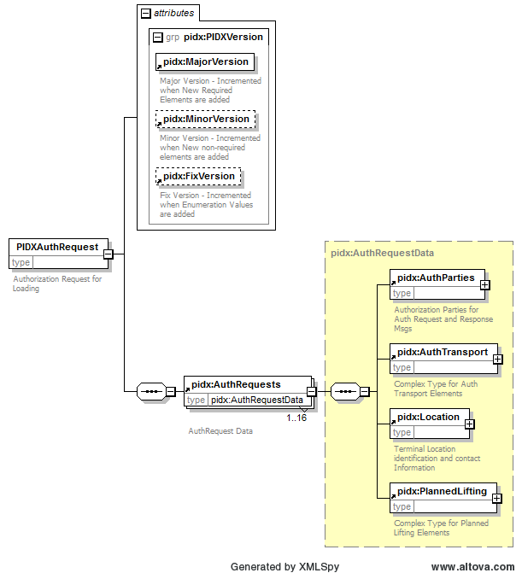

A quick overview of the structure shows the primary data categories are:
- AuthParties – This is where seller, buyer, stockowner, or any additional authorizing party chains can be found.
- AuthTransport – Contains information related to Carrier/Hauliers and MOT.
- Location – Contains information about where the product is being picked up from.
- Planned Lifting – LoadingType element in Planned Liftings will control what is sent back in the response.
Each section and the values to be placed in the XML elements will be discussed in greater detail in Section 2.

PIDX Authorization Response
The Basic Response Structure is shown below.
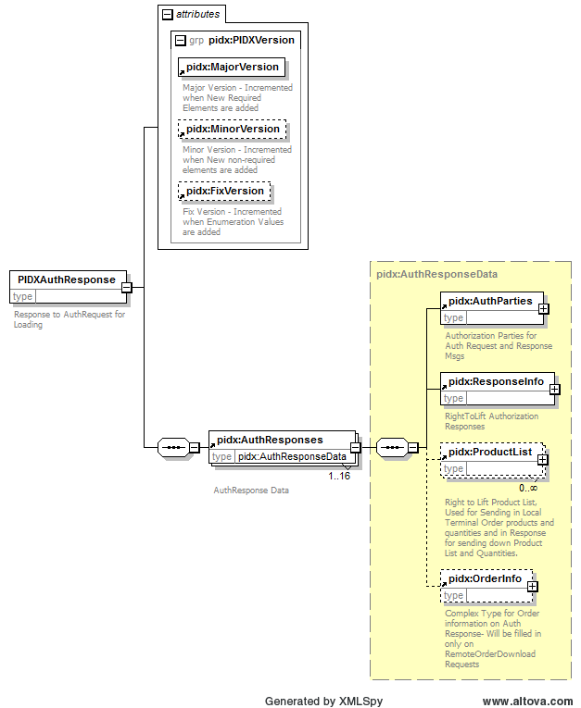
A quick overview of the structure shows the primary data categories are:
- AuthParties – This data is echoed back from the Authorization Request message.
- Response Info - Contains the Authorization Response (AUTH/DENY), as well as supporting information for the Response in the form of an Error or Authorization Number.
- Product List – The product list contains the list of products and potential amounts to be loaded. The Loading Reference ID should is related to the product being loaded and should be returned with any products loaded against the product listed.
- Order Info – If the LoadingType was RemoteRealtimeDownload, then the entire order or shipment from the Clearing House will be placed in the Response.

PIDXBOL
The Data structure for the PIDX BOL is quite complex and is contained in a separate file. The Primary sections of the BOL record are listed below:
- Action Code – Contains information related to what the type of data is in the document.
- The header record contains Document Data related to action code.
- Location Data – Terminal/Depot data
- Document Reference Data (contained in various elements on the root portion of the document).
- Partner/Party data – Seller/ThirdParty/Consignee – Are Required (if ThirdParty is available which would be the party the Seller is purchasing Product From), Optional Seller specific data can be specified as well, like Soldto, ShipTo, and DeliveredTo data.
- Activity Timing – Contains Timing related data in local terminal time zone.
- Transport Data – This is a complex structure that contains the Haulier and Engine information as well as the products loaded on the transport. Within the LoadingParts section (which would be the trailer if the MOT was Truck), the following data sections are referenced.
  - Loading Part Identification – Identifies information related to that loading part or trailer.
  - Contents – The contents for the Loading Part are contained in another primary section with the following primary elements.
    - Compartment or Aggregate Product Information (Compartment ID or Line Item Number)
    - References – Line Item References (Product Level or line item level data for Shipments or Orders)
    - DetailPartners – Could be related to delivery of product to a party, or shipto/soldto data for shipments with multiple unrelated drop offs.
    - Product – Product Level Data for that Compartment or Line item (mostly product codes and product references)
    - Tax Data for the Product
    - Measurement Data which includes a Recipe Section for Component level details.
    - Left on Board Product Data

PIDXBOLResponse
The basic structure is shown below.
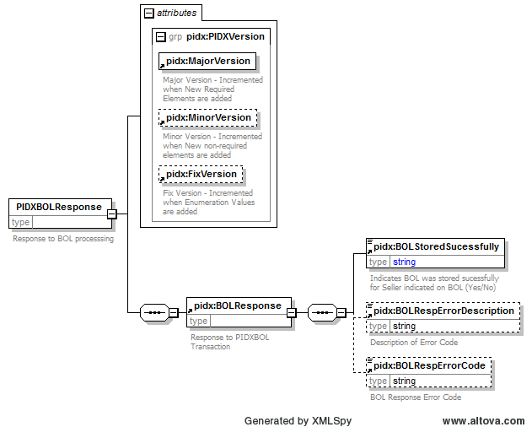

The BOLResponse simply informs the Terminal if the BOL was accepted by the clearing house. If it was accepted then the StoredSucessfully Flag will be set to Yes, if not the flag will be set to No and the TAS system should notify an operator of a BOL issue. The Primary field that will cause a NO response is the Seller Number not being filled in correctly. The Clearing House should be able to route all other BOL error messages internally to be fixed by the seller, but if the seller number is not set correctly, then the BOL cannot be routed to the correct seller to resolve the issue or contact the TAS owner.

Detailed Element Data Population Recommendations
The following sections contain data and scenarios for picking up product based on the various LoadingTypes. The Party and Order Information contained in this section will be referenced throughout the examples. Party information contains information related to the purchasing, selling parties, terminal, and Carrier specific data..

Party Information
Party Type | Party Name | PIDX Identifier | Other Identifier
Seller | XYZ Oil Company | 001 | None
Customer | ABC Fuels Distribution | 12345678
Location/Terminal/Depot | Tanks RUS | TGB001234 | Terminal Owner = 002 (Tanks RUS)
Carrier/Haulier | CYW Trucking |  | Terminal Haulier ID = 000001
Engine Data |  |  | License# = ABCDEF
Trailer Data |  |  | License#=TRLABC  Size = 34,000 Liters

Order Information
Note the order information can be for a shipment or for a pre-order where the pre-order may be a wholesaler delivering to multiple sites. For orders, the Party information for Seller, Customer and Location is implied. The Carrier/Driver fields are specified in the order to show how the various scenarios could work.

Order# 10001 – Priority 10
Party | Party Name | License#
Carrier | CYW Trucking | ABCDEF
Driver | SMITH | DriverLic: ABC123  DriverCardNo:1003
OrderLine# | Location | Product | Quantity
1 | Site Loc#1 | UL95/P23 | 11000 litres
2 | Site Loc#2 | UL87/D5E | 23000 litres

Order #10010 – Priority 1
Party | Party Name | License#
Carrier | CYW Trucking | ABCDEF
Driver | JONES | Driver Lic: XYZ123  Driver Card: 501
OrderLine# | Location | Product | Quantity
1 | Site Loc#11  1234 1st St  Omaha, NE 68114  Ship To = 111222 | UL95/P23 | 17000 Litres
2 | Site Loc#21  4567 10th St  Council Bluffs, IA 51501  Ship To = 111333 | UL87/D5E | 17000 Litres

Scenarios using the LoadingType field:
In the Authorization Request message structure; there is one key data field which will determine the type of loading which was requested by the driver. The content of the Authorization Response is highly dependent on this field. Below is a description of the 3 possible enumerations for the LoadingType field:
- RackPickup – This common loading type is used when the order being loaded is not stored in the terminal automation system or the clearing house. The order is simply entered by the driver at the rack at the time of loading. The seller does not require the customer to enter the order in advance, but the seller will require the customer to be authorized at the loading rack.
This loading type may or may not have an order number entered in the Planned Lifting section. If the order number is entered, it will simply be used as a reference in the clearing house and will be stored on the BOL returned to the Clearing house.
- RealTimeRemoteOrderDownload – This loading type is used when the order details are stored in the clearinghouse, not in the terminal automation system. After receiving the Authorization Request, the clearing house will push an order to the terminal automation system in the Authorization Response message structure.
  - Order Number Populated – If the order number included in the Authorization Request and the order is found in the clearing house, the clearing house will include all the order details in the Authorization Response message in the OrderInfo Section. Aggregate amounts for the products on the order will also be returned in the ProductList section. The loading of product should be limited to the amounts in the ProductList section unless the amounts are unspecified in which case the order should be treated as a RackPickup Authorization (load as much of each product as necessary).
If the order number included in the Authorization Request message is not found in the clearing house, the clearing house will send a DENY message to the terminal in the Authorization Response message with an error code of Order Number Not Found, Please verify the number is correct.
Note: ALL leading zeros will be stripped from Order Numbers enter in the system to alleviate false error codes, trailing zeros should be entered.
  - Order Number Not Populated – If the order number is not included in the Authorization Request message, the clearing house will include all the order details for the next applicable order for that terminal, customer, driver, or haulier in the Authorization Response message sent to the terminal automation system. Since the Data Clearing house is auto picking the order, all available party information for terminal, seller, consignee, soldto, shipto, carrier and driver, MOT information should be included in the request so the system can return the correct data to the end user.
- LocalTerminalOrder – This loading type is used when the order details are stored locally in the terminal automation system. When using this LoadingType, the order number, products and requested quantities should be populated in the Authorization Request message.
Depending on the implementation of the clearing house, the Authorization Response message will include a list of the authorized products. The TAS will then validate that all the products on the order were authorized by the clearing house and indicate to the driver if the entire load can or cannot be picked up for this order. Alternatively, the clearing house may Deny the order if any or all of the products on the order are not available for loading. In this situation, a Deny error message stating that “All products for specified order are not available” should be sent from the clearing house.
See Spread Sheet for XML Sample Files

AuthParties structure
When multiple parties are involved in the transaction, there are some conventions which should be followed in the population of the party data in the Right to Lift messages.
There are 3 AuthParties listed in the Authorization Request message:
- SellerNum – the seller number is the PIDX seller number which represents the contract owner at the terminal. This is the company which has the relationship with the customer purchasing the product.

- FinalShipper – the final shipper number is also a PIDX seller number which represents the final seller account in the clearing house which should be checked as part of the authorization request.

- Consignee – the consignee is the unique identifier of the customer which will typically be assigned by the seller and manually maintained in the TAS by the terminal owner.

The SellerNum and FinalShipper fields are populated with different values depending on the supply relationship at the terminal and the architecture of each of the parties involved.

One Party Example
In the one party example, there is only one party in the supply relationship which has a relationship with the clearing house. So, the SellerNum field will be populated with the PIDX seller number and the FinalShipper field can either have the seller number or be left blank. If blank, the data clearinghouse will determine the FinalShipper.

Two Party Example
In the two party example, there are 2 parties in the supply relationship which have a relationship with the clearing house. In this case, the PIDX seller number which represents the contract owner would be placed in the SellerNum field. The other party (usually an exchange partner from which the contract owner is lifting) shall have their PIDX seller number placed in the FinalShipper field.

Cancelled Loads – No Load BOLs
In some cases when the clearing house is authorizing drivers, the products required by the driver to load are not available after authorization. In these situations, the driver may abort or cancel the loading because he cannot load according to his plan.
When the driver cancels or aborts a load after the clearing house has sent an AUTH message to the terminal automation system, the TAS shall send a No Load BOL back to the clearing house. This process will allow the clearing house to ‘close out’ the authorization and reset any processing on their side which was dependent on receiving the actual BOL. A No Load BOL is the standard BOL message with the AuthorizedLoad field set to “NoLoad” and the AuthorizationNo field populated with the authorization number from the authorization response message. The DocumentIdentifier in the PostingReference section would also be blank.
A No Load BOL is not required when a DENY message is sent to the terminal automation system as no loading can happen on a DENY message in the Authorization Response.

